Install: <https://www.apachefriends.org/download.html>

Follow the prompts to install.

Once installed Open the Directory Folder for Xampp > htdocs:

It should look similar to this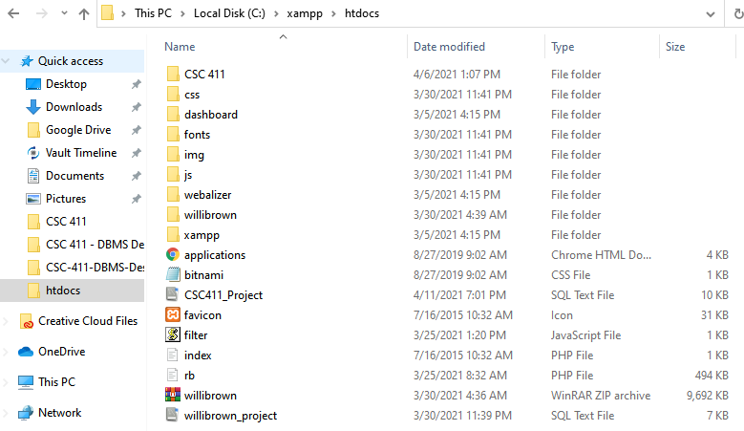

Download the most current course project from: <https://github.com/LoRTiFDaft/CSC-411-DBMS-Design>

Copy and Paste the CSC 411 folder and the CSC441_Project.sql file in the > htdocs folder.

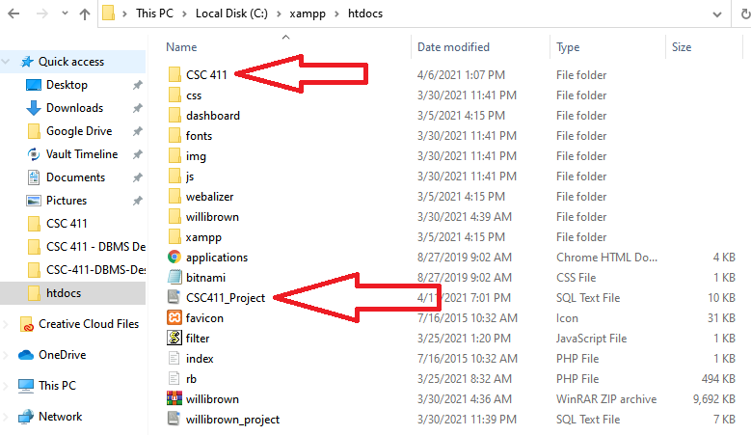

Start and Run the Xampp Server Control Panel: Start the Apache Server and MySql Server toggle.

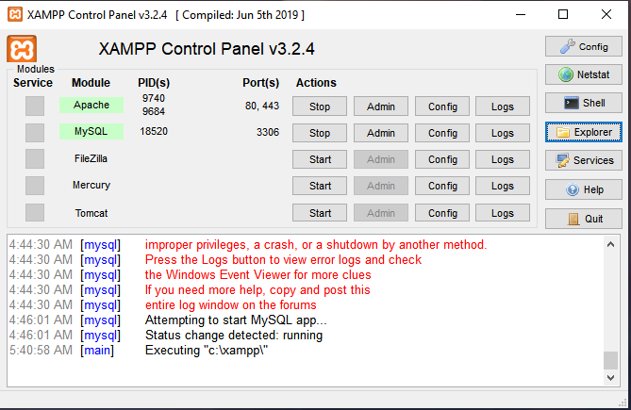 If the MySql Server will not start you will need to manually close the MySql WorkBench and go to the Task Manager to close the process depending on what you named it during installation the name may vary but mine was named “MySql60” by default.

Once the Xampp Server is started successfully. Open your default web browser, I personally use Chrome. And Type in: <http://localhost/dashboard/> to verify this screen and that it working properly.

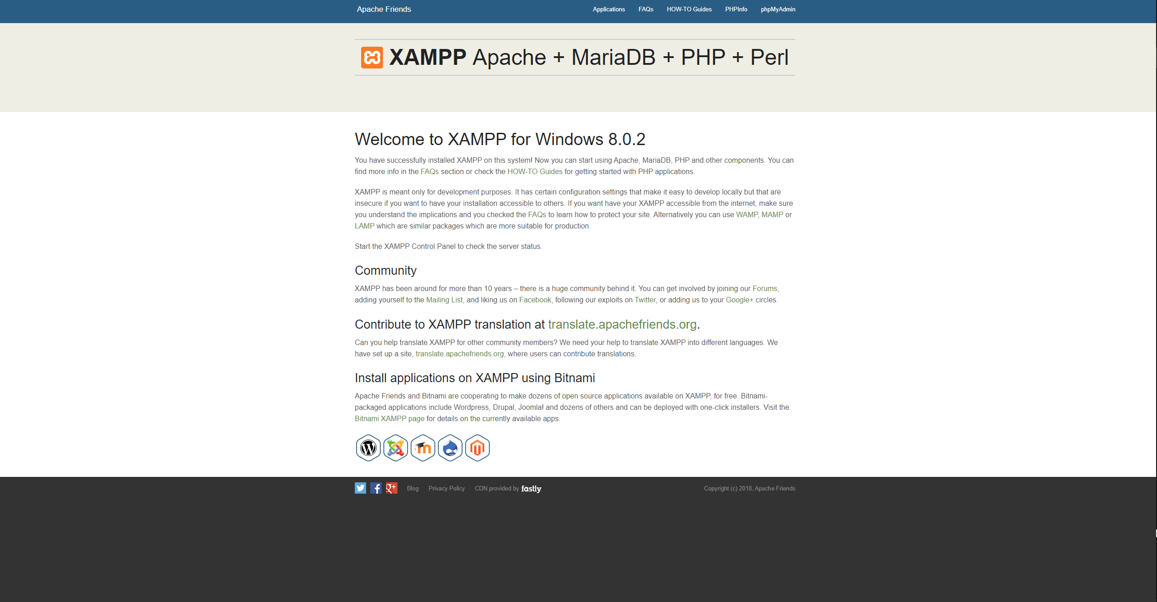

Once verified that the setup was successful, go to the link: <http://localhost/phpmyadmin/>**.** This is where you will set up your local web server.

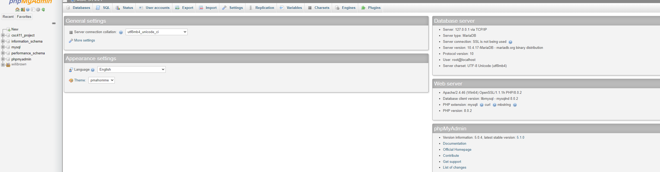

From here you will click the add new server button on the far left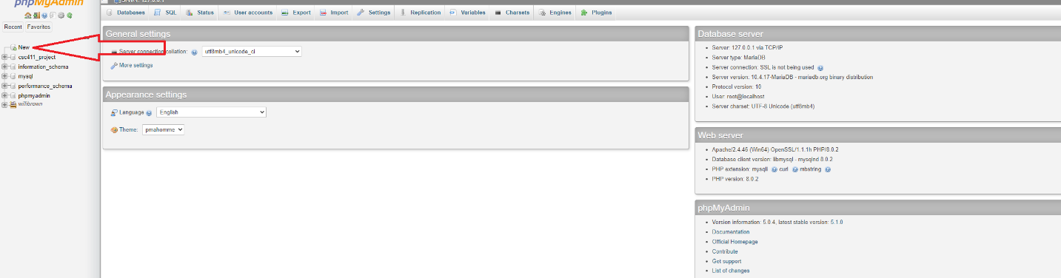

Once done you will enter the database name: CSC411_ Project and click create. Once created you will import the MySql file. By going to Import > Choose file > using the directory from the above steps to find the location of your htdocs>CSC411_Project.sql. Then click the Go button and this will import your entire Database.

Final Step to view the project is to go to your web browser once again and Type in:

[http://localhost/CSC 411/index.php](http://localhost/CSC%20411/index.php)

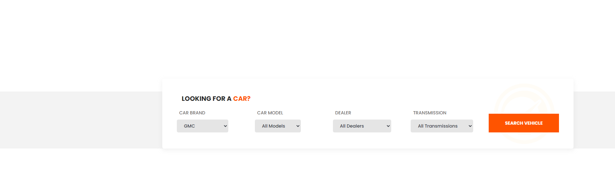

And it will bring up the project website.